Illustration request form
Please fill out the boxes below and email to creative.cp@outlook.com attaching any relevant files or links that go alongside the request. I will get back to you as soon as I can and typically book in a follow up online meeting to discuss the request in more detail.
Name
Organisation/company/role
Date
Contact details
Hoped timescale (e.g. tight – I need it done within a few weeks)
Project name (e.g. images for report on X/illustrating a book titled…)
Purpose of commission
Summary of hoped outcome e.g. 5 simple illustrations for a report/a complex illustration of

Description of Request
Please include as much detail here as possible. This can include rough sketches of what is hoped for. Sometimes people do not have a fixed image in mind and this is also fine. I am happy to draw on my psychology expertise and plan in a collaborative way. But please give an overview of hoped messages of images etc. Half formed thoughts and ideas are welcomed too. Please attach additional pages if this box is not big enough.

Any other relevant information
What is the timescale?
Do you have a limited budget?
Will this be a one off or regular commission?
Do you have any needs when discussing the commission request?

Costs
The price list below is a guide only and a final cost will be agreed before work is started
Set costs for illustrations is difficult because the time taken to complete will will depend on the level of detail. However, below is a rough guide based on a charge of £35ph. Cost estimates are inclusive of all my costs and also time for reasonable adjustments e.g. colour.
Please let me know if you have a limited budget and I am happy to discuss being flexible. In some cases e.g. social justice orientated work where there is no budget, I will offer my time for free. Please get in touch to discuss.
Size/type of image/service | Example | Cost
Simple | 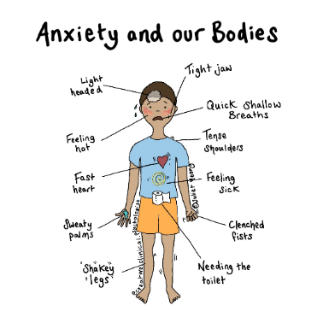 | £35-70
Medium detail | 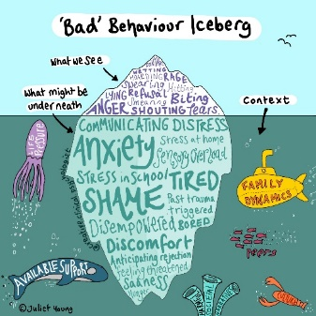 | £70-140
Complex detail | 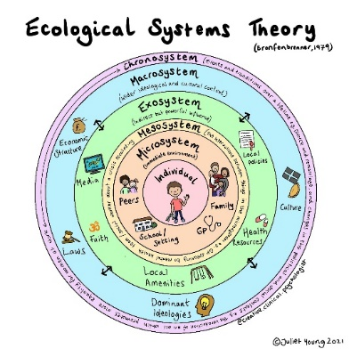 | £140-£200+
Creative development | Time spent developing sketches and combining psychological knowledge with illustration | £35ph
Creative consultation | Advice and guidance on imagery before request is submitted. | £35ph
Extra time | If an initial idea is changed and significantly more time is needed to make adaptions | £35ph
Reusing an existing drawing in a semi-permanent publication* | e.g. training handouts/leaflet for business | £0-30
Copyright permission for use of an existing image in a book |  | £100 (negotiable)
Adaption of existing drawing** |  | £35+ (depending on level of adaption required use of drawing and how long it takes)
Copyright permission for use in a commercial training presentation* |  | £10-30
Copyright permission for other uses e.g. websites, booklets etc |  | P.O.A
*For non-commercial purposes, I typically give this permission for free
**This is negotiable depending on the service e.g. for a small start up charity I am happy to do this for a reduced fee

